**DAY-1 EXPERIMENTS:**

1)ARITHMETIC OPERATIONS

#include <stdio.h>

int main()

{

int num1, num2;

int sum, sub, mult, mod;

float div;

printf("Enter any two numbers: ");

scanf("%d%d", &num1, &num2);

sum = num1 + num2;

sub = num1 - num2;

mult = num1 * num2;

div = (float)num1 / num2;

mod = num1 % num2;

printf("SUM = %d\n", sum);

printf("DIFFERENCE = %d\n", sub);

printf("PRODUCT = %d\n", mult);

printf("QUOTIENT = %f\n", div);

printf("MODULUS = %d", mod);

return 0;

}

OUTPUT:

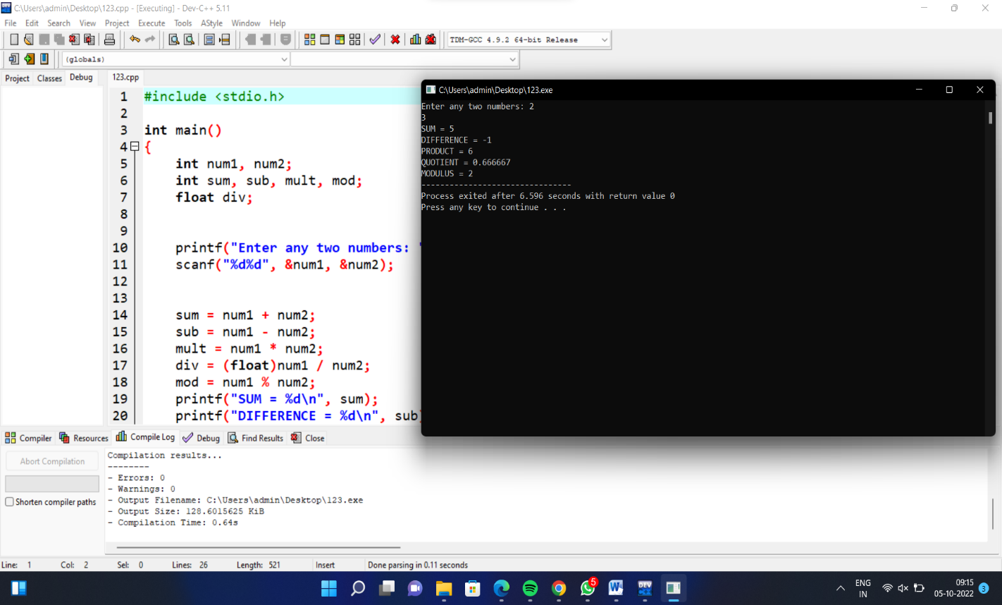

__________________________________________________________________________________

2)REVERSE NUMBERS

#include <stdio.h>

int main(){

int Num, rev_Num = 0, remainder;

printf("Enter the number to reverse: ");

scanf("%d", &Num);

while (Num != 0){

remainder = Num % 10;

rev_Num = rev_Num * 10 + remainder;

Num = Num/10;

}

printf("The reversed number is: %d", rev_Num);

return 0;

}

OUTPUT:

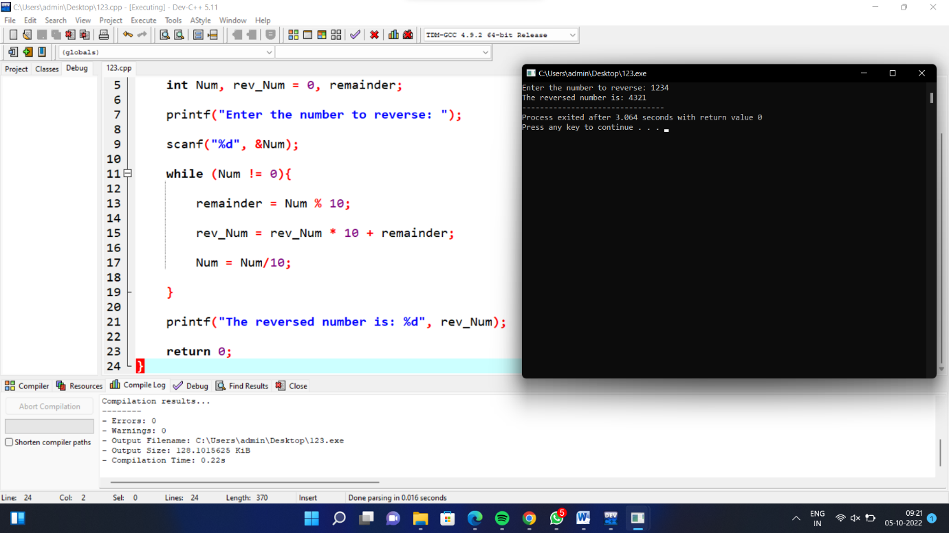

--------------------------------------------------------------------------------------------------------------

3)FACTORIAL:

#include <stdio.h>

int main(){

int i,f=1,num;

printf("Input the number : ");

scanf("%d",&num);

for(i=1;i<=num;i++)

f=f*i;

printf("The Factorial of %d is: %d\n",num,f);

}

OUTPUT:

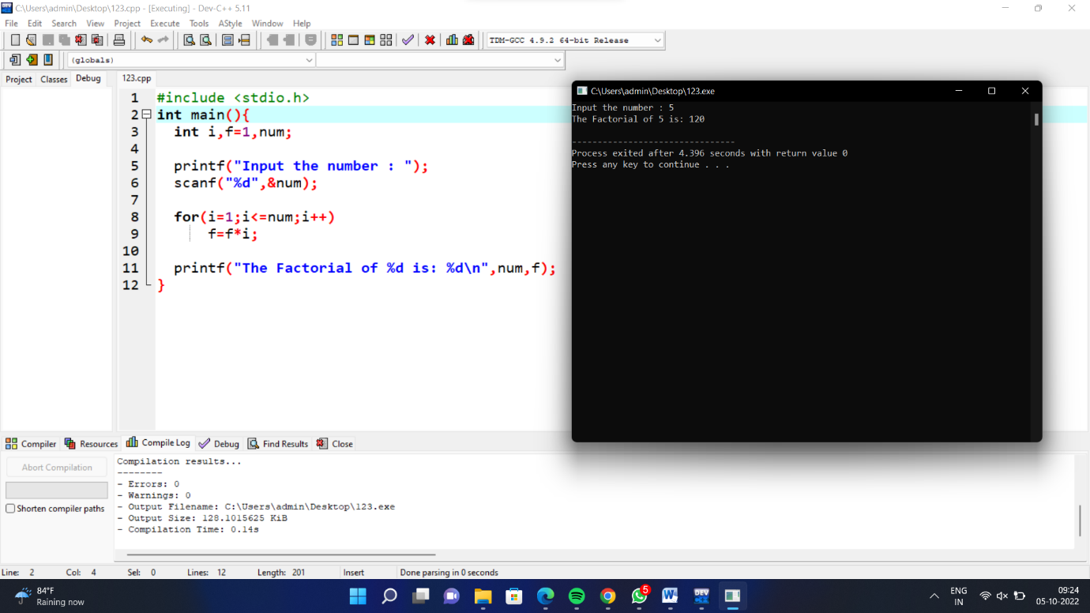

-----------------------------------------------------------------------

4)PERFECT NUMBER:

#include<stdio.h>

#include<conio.h>

void main()

{

int num, rem, sum = 0, i;

printf("Enter a number\n");

scanf("%d", &num);

for(i = 1; i < num; i++)

{

rem = num % i;

if (rem == 0)

{

sum = sum + i;

}

}

if (sum == num)

printf(" %d is a Perfect Number");

else

printf("\n %d is not a Perfect Number");

getch();

}

OUTPUT:

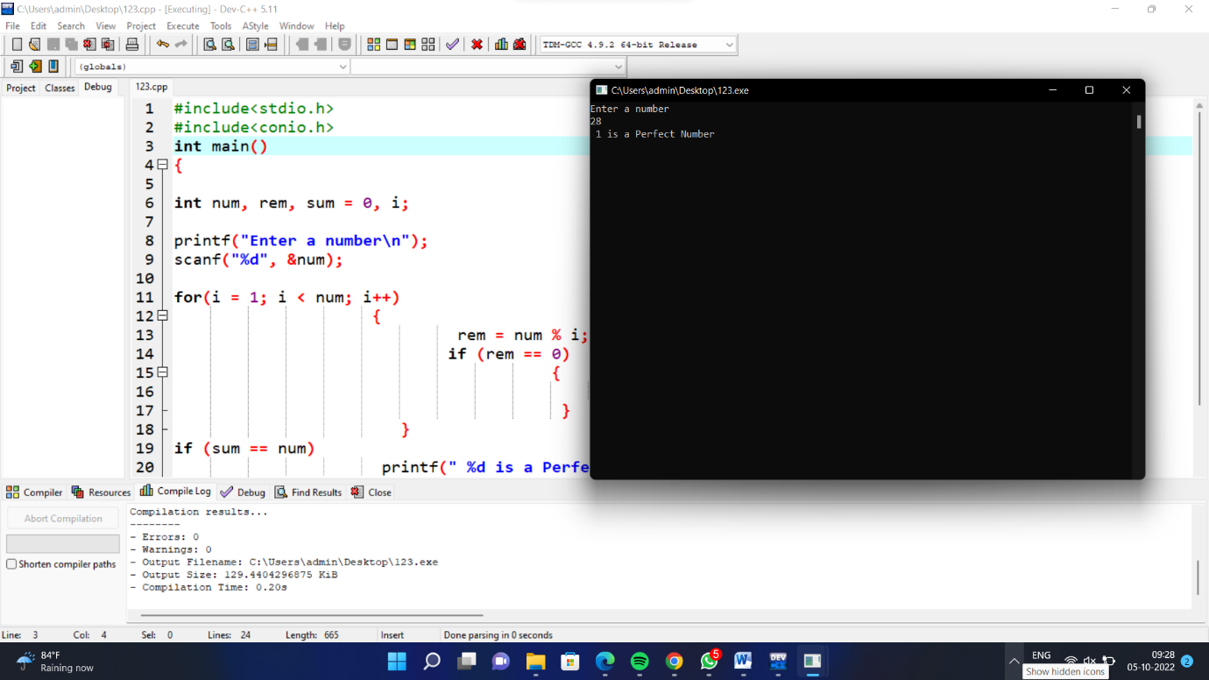

5)ELIGIBLE FOR VOTE:

#include<stdio.h>

int main()

{

int age;

printf("enter age:");

scanf("%d",&age);

if(age>=18){

printf("eligible to vote");

}

else{

printf("%d not eligigble ");

printf("%d years to wait ",18-age);

}

}

OUTPUT:

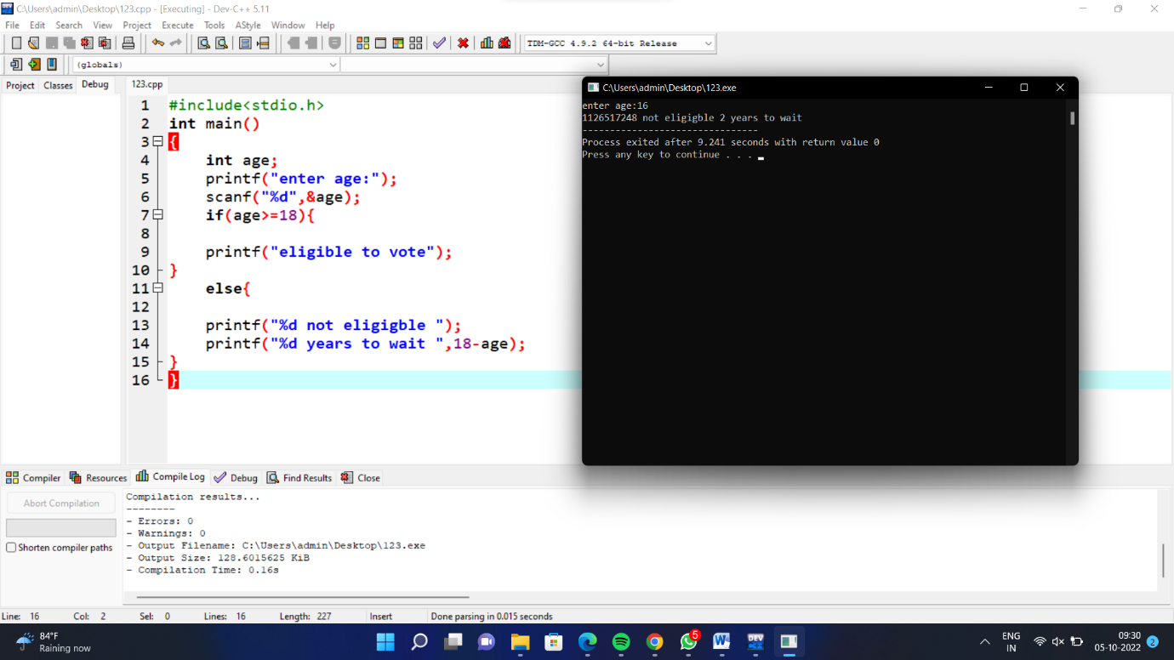

##################################################################################

6)EVEN OR ODD NUMBER:

#include <stdio.h>

int main() {

int num;

printf("Enter an integer: ");

scanf("%d", &num);

if(num % 2 == 0)

printf("%d is even.", num);

else

printf("%d is odd.", num);

return 0;

}

OUTPUT:

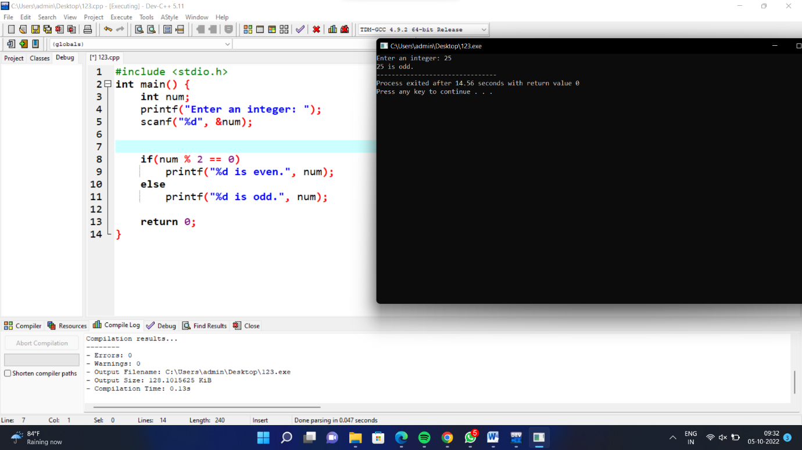

**********************************************************************************

7)P TO Q STATEMENT:

#include<stdio.h>

int main()

{

int p,q,r,i,c=0;

printf("Enter P :");

scanf("%d",&p);

printf("Enter Q :");

scanf("%d",&q);

printf("Enter R :");

scanf("%d",&r);

for(i=p;i<=q;i++)

{

if(c!=r)

{

printf("%d ",i);

c++;

}

else

{

c++;

continue;

}

}

return 0;

}

OUTPUT:

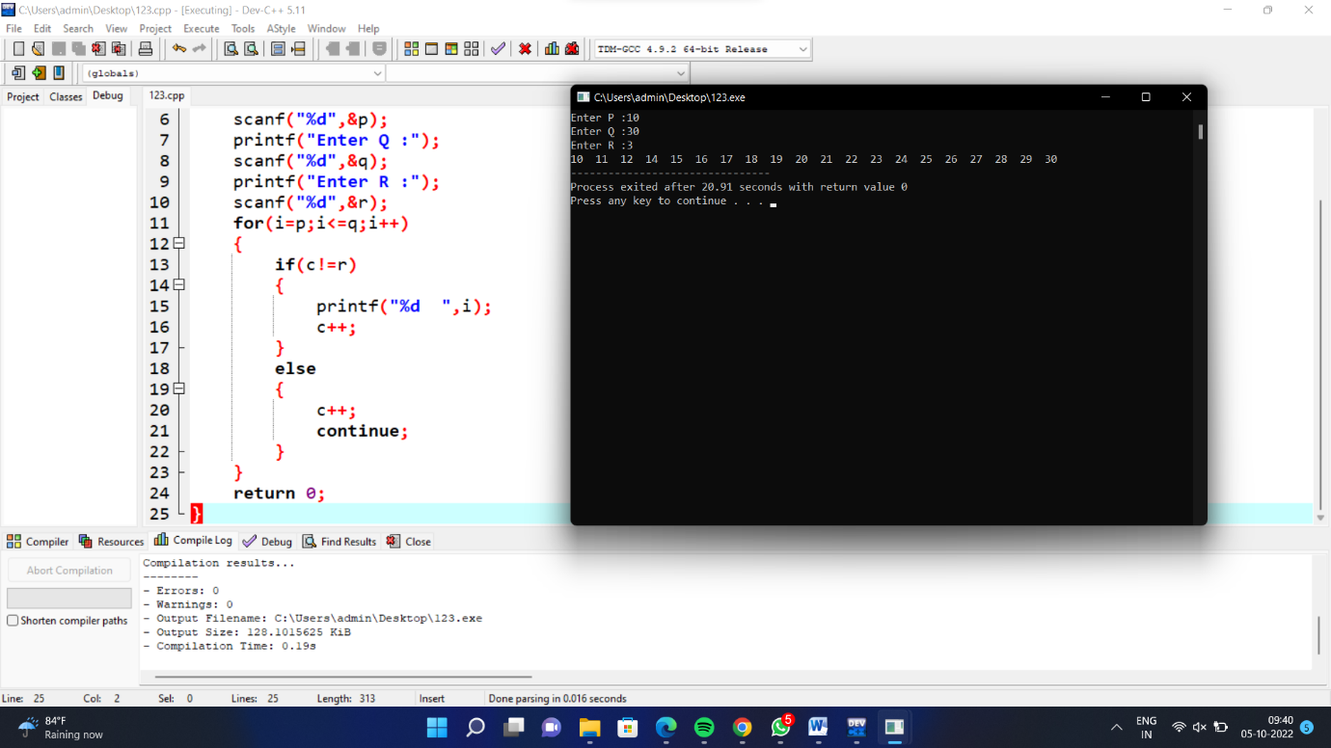

**********************************************************************************

8)MULTIPLICATION TABLE:

#include <stdio.h>

int main() {

int n, i, range;

printf("Enter m: ");

scanf("%d", &n);

do {

printf("Enter n: ");

scanf("%d", &range);

} while (range <= 0);

for (i = 1; i <= range; ++i) {

printf("%d * %d = %d \n", n, i, n * i);

}

return 0;

}

OUTPUT:

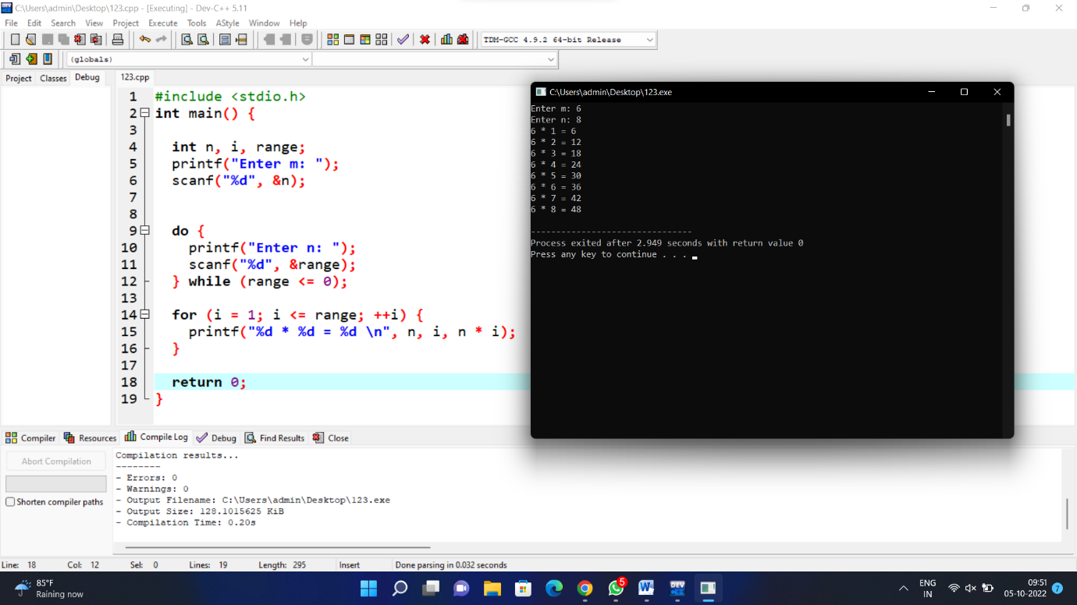

**********************************************************************************

9)LEAP YEAR:

#include <stdio.h>

int main() {

int year;

printf("Enter a year: ");

scanf("%d", &year);

if (year % 400 == 0) {

printf("%d is a leap year.", year);

}

else if (year % 100 == 0) {

printf("%d is not a leap year.", year);

}

else if (year % 4 == 0) {

printf("%d is a leap year.", year);

}

else {

printf("%d is not a leap year.", year);

}

return 0;

}

OUTPUT:

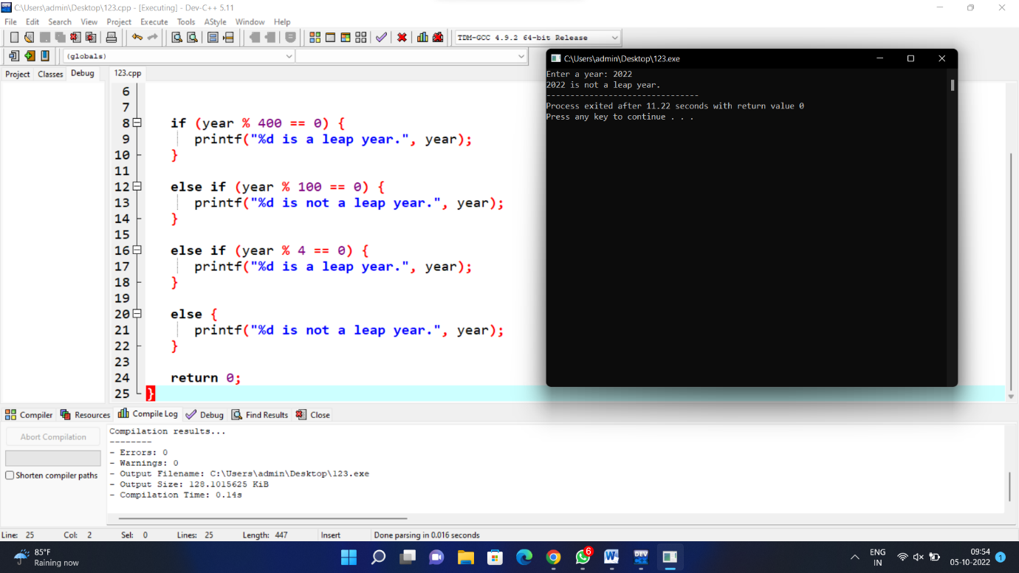

**********************************************************************************

10)SUM OF DIGITS:

#include <stdio.h>

int main()

{

int n, t, sum = 0, remainder;

printf("Enter an integer\n");

scanf("%d", &n);

t = n;

while (t != 0)

{

remainder = t % 10;

sum = sum + remainder;

t = t / 10;

}

printf("Sum of digits of %d = %d\n", n, sum);

return 0;

}

OUTPUT:

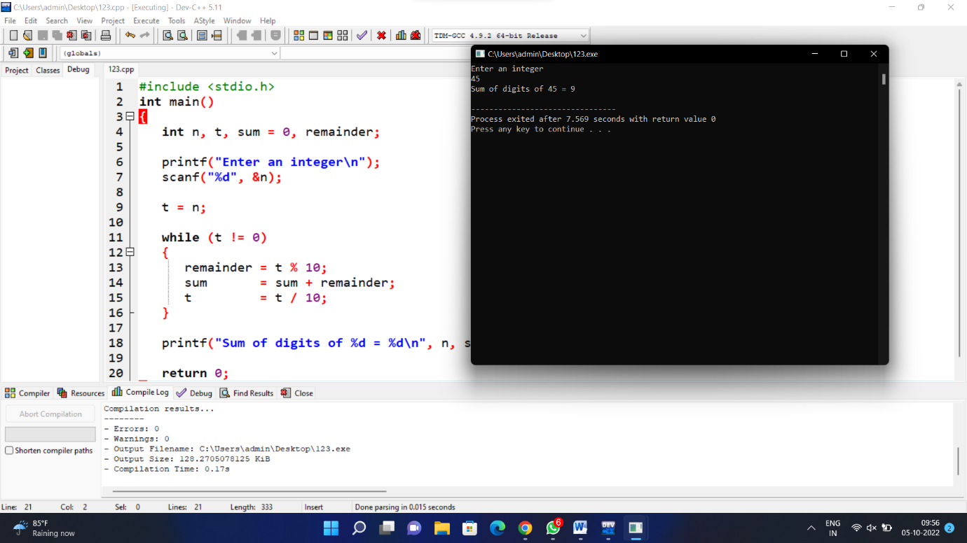

**********************************************************************************

11)PERMUTATION:

#include <stdio.h>

#include <string.h>

void swap(char *x, char *y)

{

char temp;

temp = *x;

*x = *y;

*y = temp;

}

void permute(char *a, int l, int r)

{

int i;

if (l == r)

printf("%s\n", a);

else

{

for (i = l; i <= r; i++)

{

swap((a + l), (a + i));

permute(a, l + 1, r);

swap((a + l), (a + i));

}

}

}

int main()

{

char str[] = "ABC";

int n = strlen(str);

permute(str, 0, n-1);

return 0;

}

OUTPUT:

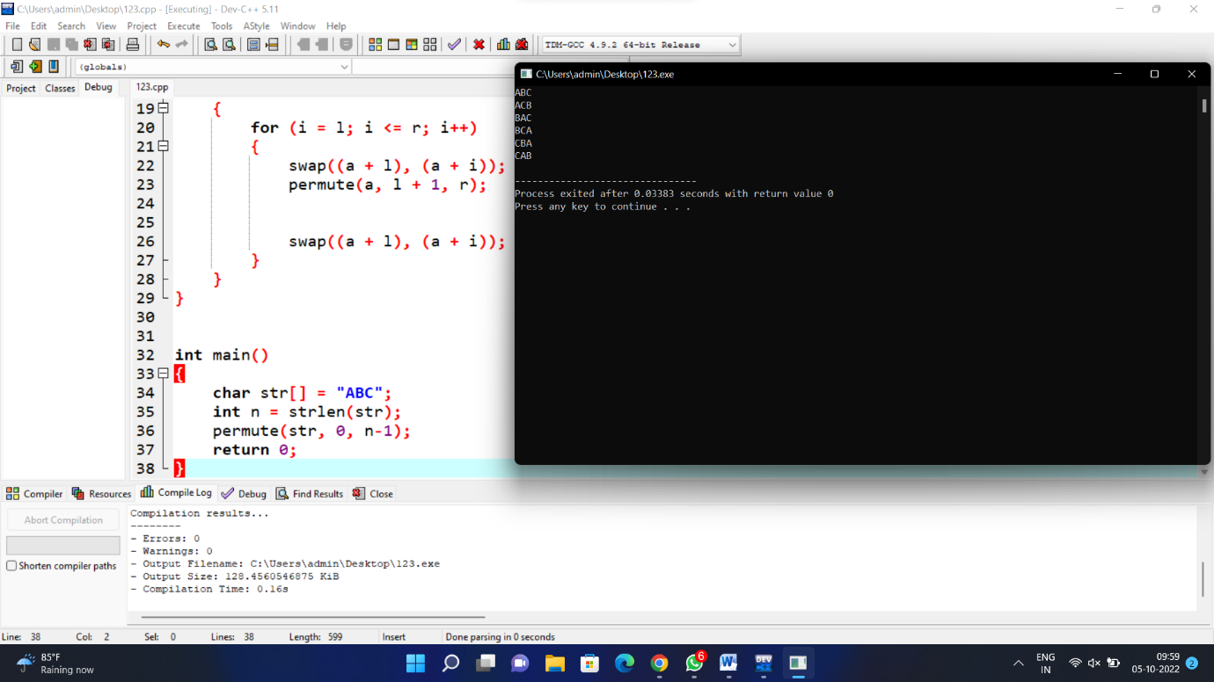

**********************************************************************************

12)SIMPLE INTEREST:

#include <stdio.h>

int main()

{

float principle, rate, sinterest;

int time;

printf("Enter Principle Amount, Rate %% per Annum and Time\n");

scanf ("%f %f %d", &principle, &rate, &time);

sinterest = (principle * rate * time)/ 100.0;

printf ("Principle Amount = %5.2f\n", principle);

printf ("Rate %% per Annum = %5.2f%\n", rate);

printf ("Time = %d years\n", time);

printf ("Simple Interest = %5.2f\n", sinterest);

}

OUTPUT:

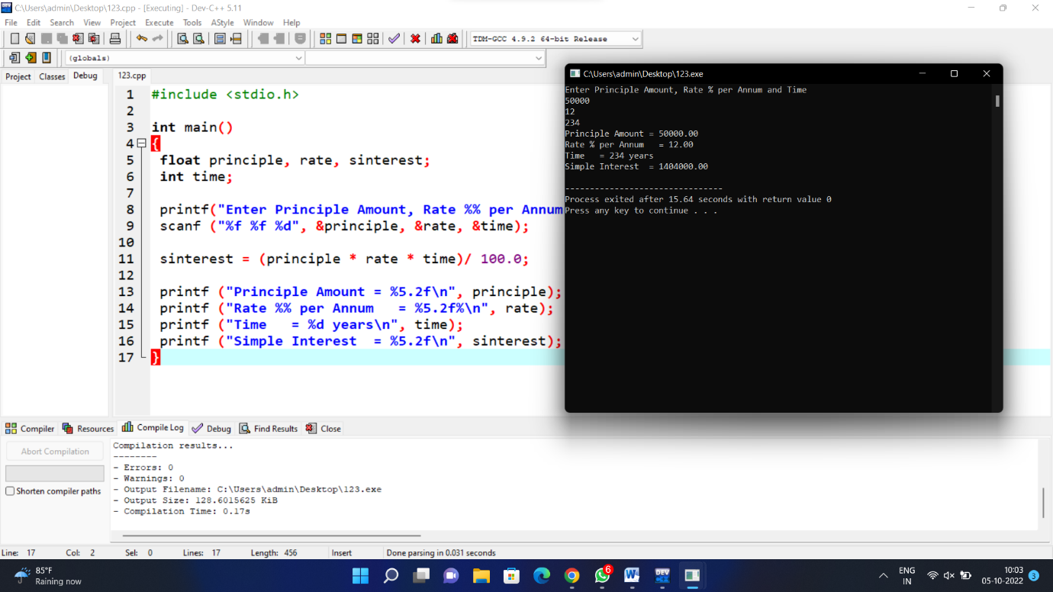

**********************************************************************************

13)STRONG NUMBER:

#include <stdio.h>

int main()

{

int i, originalNum, num, lastDigit, sum;

long fact;

printf("Enter any number to check Strong number: ");

scanf("%d", &num);

originalNum = num;

sum = 0;

while(num > 0)

{

lastDigit = num % 10;

fact = 1;

for(i=1; i<=lastDigit; i++)

{

fact = fact * i;

}

sum = sum + fact;

num = num / 10;

}

if(sum == originalNum)

{

printf("%d is STRONG NUMBER", originalNum);

}

else

{

printf("%d is NOT STRONG NUMBER", originalNum);

}

return 0;

}

OUTPUT:

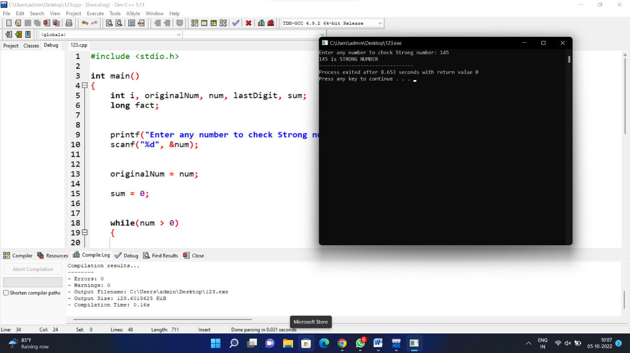

**********************************************************************************

14)NTH PRIME NUMBER:

#include <stdio.h>

#include<math.h>

int

main ()

{

int rangenumber, c = 0, num = 2, i, letest = 0;

printf ("Enter Nth Number\n");

scanf ("%d", &rangenumber);

while (c != rangenumber)

{

int count = 0;

for (i = 2; i <= sqrt (num); i++)

{

if (num % i == 0)

{

count++;

break;

}

}

if (count == 0)

{

c++;

letest = num;

}

num = num + 1;

}

printf ("%dth prime number is %d ",rangenumber,letest);

return 0;

}

OUTPUT:

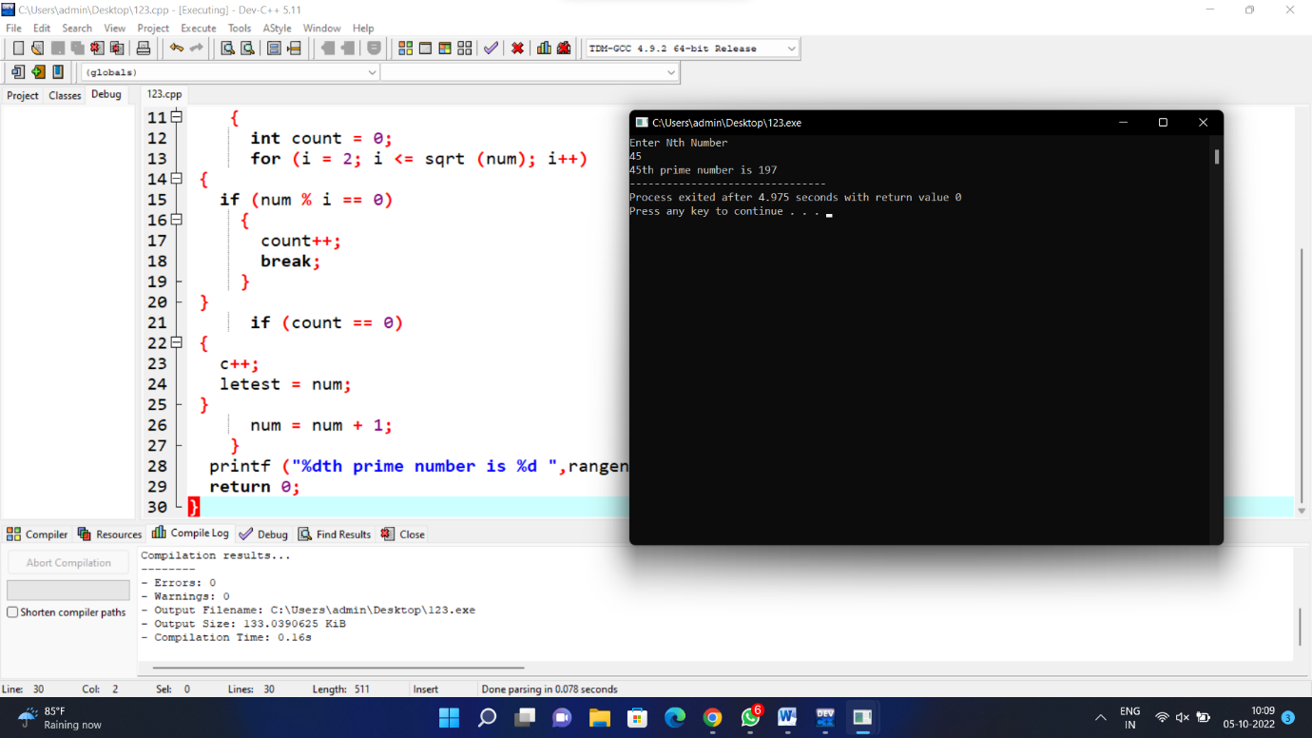

**********************************************************************************

15)PYTHAGEROAN:

#include<stdio.h>

main(){

int initial,final,a,b,c,m,n;

printf("Enter the range in which you want to search for Pythagorean Triplets:\nInitial: ");

scanf("%d",&initial);

printf("\nFinal: ");

scanf("%d",&final);

printf("The Pythogorean Triplets in the given range are as follows:\n____________________________________________________________\n");

for(m=initial;m<=final;m++){

for(n=initial;n<=final;n++){

a=m*m-n*n;

b=2*m*n;

c=m*m+n*n;

if(a<=final&&b<=final&&c<=final&&a>=initial&&b>=initial&&c>=initial){

printf("%d , %d , %d\n",a,b,c);

}

}

}

}

OUTPUT:

